This home exercise programme has been provided to you by your physiotherapist _________________. We recognise that keeping active and maintaining your usual routine currently has its challenges. We hope that this programme helps you and your whole family to be as active and as healthy as possible, and of course to have fun!!
Our GOAL is that we continue to get 60 minutes of fun activity per day.
Also don’t forget, let’s try to get 10-12 hours of sleep per night. It will help if you try to keep bed times the same as your normal school routine.
Here are some ideas to help you all have a FUN 60 minutes.
- ANIMAL RACES
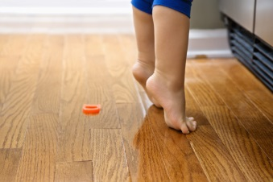
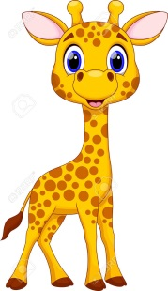
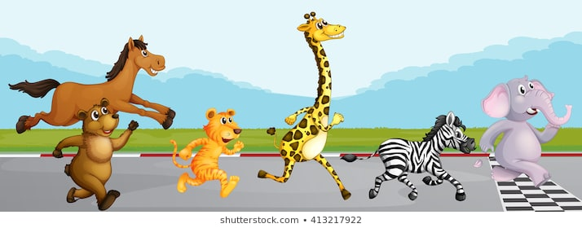
Put the names of all of the animals below on pieces of paper (or even better, draw a picture of each of them!). Place all the pieces of paper in a bowl and take turns picking out an animal. Don’t forget to make the noise of the animal too! Have a think about what other animal you could be too. Once you have mastered each of the animals, have animal races with your family !!
- Giraffe walk – walk on your tip-toes with arms overhead, try to be as tall as you can and touch the ceiling
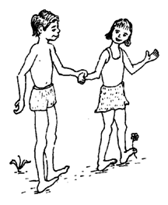

- Penguin walk – walk on your heels like a penguin. Make sure your toes are pointing straight up towards the ceiling. And don’t forget your wings !
- Bunny hops – imagine your two feet are super glued together, jump like a bunny with two feet together. Extra challenge : bunny has a sore leg, can you hop on one leg ??

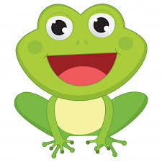
- Frog jumps- squat down as low you can and then jump up and try to touch the ceiling. See who can jump the highest and the furthest ?
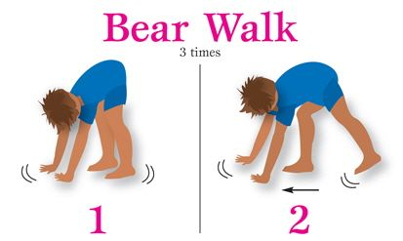

- Bear walk – walk on your hands and feet like a big, scary bear
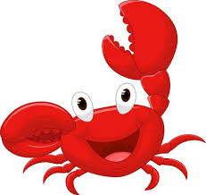

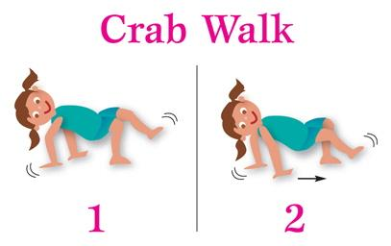
- Crab walk- put a teddy on your tummy and walk like a crab without letting the teddy fall off. Once you have mastered going forwards and backwards, see can you go sideways like a real crab.
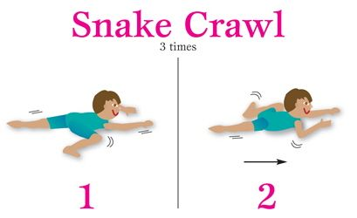
- Snake crawls – lie on your stomach and use your arms only to slither along the ground like a sssssssssnake.

- BALANCE
- Practise standing with one foot on a football. See can you hold for 10 seconds with each foot.
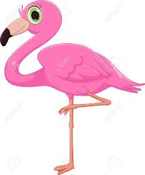
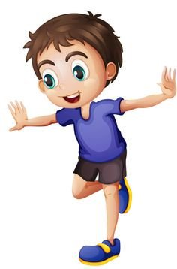
- Once you can do 10 seconds, practise rolling the ball with a family member. You have to trap the ball with your foot as it rolls towards you, and then roll it back to your partner.
Put a teddy/beanbag on your head to make this more fun, see who can keep it on their head the longest!
- Flamingo – stand on one leg for as long as you can without holding on. Can you get 10 seconds on each foot ?

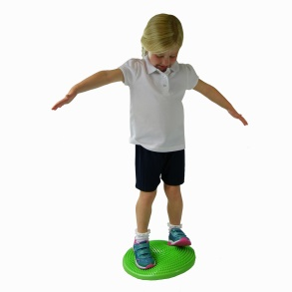
- When you can do 10 seconds with your eyes open, see can you do it with your eyes closed. Somebody can be close by to make sure you don’t fall over.
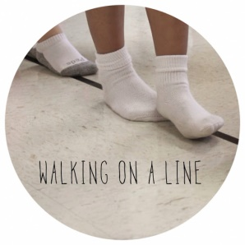
- Can you stand on something squishy like a cushion from the couch without falling over. Do this in your barefeet to feel how squishy it is ! When you get really good at this, can you stand on one leg on the cushion ?

- Practise walking heel to toe along a line at home, make sure you don’t let the teddy/beanbag fall off your head. When you have mastered this, see can you do it backwards.

- OTHER FUN GAMES
- Make up a new dance routine every day. Each person at home gets a turn at picking out a song. Everybody join in.
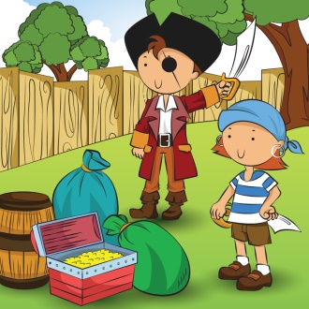
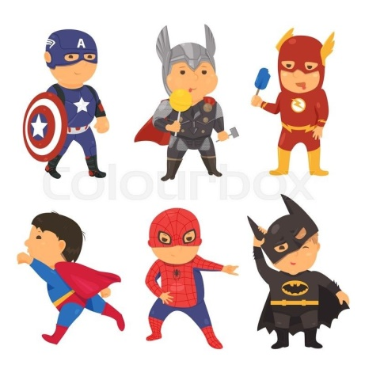
- Treasure hunts and hide and seek in the house and garden (if you have one!). There are lots of places you can hide in the house if you don’t.

- Play Charades with your family. Practise acting out cartoons/animals/dinosaurs/superheros. Remember you’re not allowed to say anything or make any noises. See if your family can guess who you are ??

- If you have space in your garden, or live within 2km of a park, practise on your bike/scooter. You can also do some ball games with your family!

- Can you make an obstacle course ??
- If you have some balloons at home, play a game of hot potato. Practise keeping the balloon up off the ground with your family by using a different body part each time eg hands, elbows, knees, head.

- Remember, you can also help your family to keep the house tidy now that everyone is at home. You can think up fun games to do while doing this.
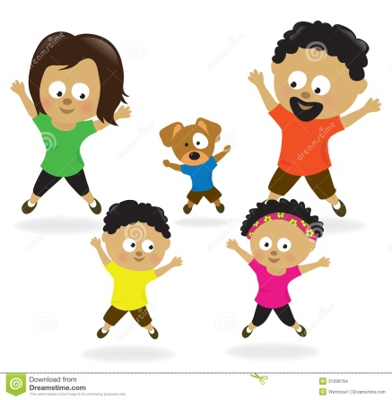
- Remember to use your imagination! You will have the best ideas for how to make fun activites for everyone in your family!

