This home exercise programme has been provided to you by your physiotherapist _________________. We recognise that keeping active and maintaining your usual routine currently has its challenges. We hope that this programme helps you and your whole family to be as active and as healthy as possible.

Our GOALS are:
- that we contine to aim to achieve 60 minutes of activity per day
- that we reduce our sedentary time by trying to keep screen time under 2 hours per day
- that we continue to aim to get 9-10 hours of sleep

Some TIPS for:
- Sleep - get to bed at the usual time for school, and get up at the usual time, turn screens off 1 hour before bed

- Eating Well- eat regular healthy meals at the usual times, have age-appropriate portion sizes, limit energy-dense, nutrient poor foods and drinks, get involved in cooking and learning new recipes

- Drinking Well- drink 2 litres of water each day

- Relaxing- get outside for fresh air and sunshine (even through clouds!), do some colouring/painting/crafts/jigsaws, read a book or comic, sing / dance / tell jokes, chat to your family if you have any worries

- Setting Goals - continue to set weekly goals as a family to help you to stay on track. Use your Top 10 Tip Sheet to help you to identify areas you can work on as a family.

We hope some of the ideas in this booklet will help you to achieve your 60 minutes of activity per day, without leaving your house or garden if needed, or going beyond 2km as per the current regulations.

- Stretches – do these stretches at least twice per day, as you are still getting taller it is important that you keep on top of your stretching so that your muscles don’t get tight and sore.
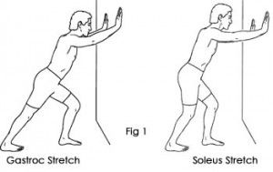
Calf Stretches –
A) Stand with one foot in front of the other, and toes pointing towards the wall. Keep your back knee straight as you lean in towards the wall. Make sure to keep your heels on the ground. Hold for 30 seconds and repeat 5 times on each leg.
B) Stand with one foot in front of the other, and toes pointing towards the wall. Keep your back knee bent as you lean in towards the wall. Make sure to keep your heels on the ground. Hold for 30 seconds and repeat 5 times on each leg.
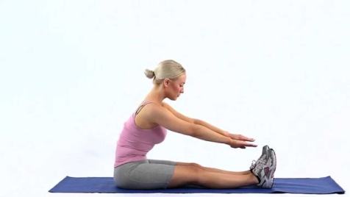
Hamstring Stretches –
A) Sit with your legs together, and knees straight, with toes pointing up towards your head. Slowly lean forwards while keeping your knees straight. Only go as far forwards as you can keep your knees straight. Remember to keep breathing normally. Hold for 30 seconds and repeat 5 times.
B) Sit with one leg bent, and the leg to be stretched out straight. Keep your knee straight and toes pointing up towards your head as you lean forwards. Remember to keep breathing normally. Hold for 30 seconds and repeat 5 times on each leg.
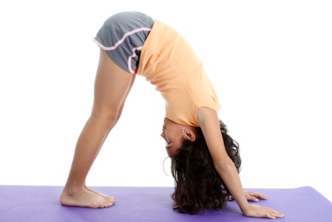
Whole Body-
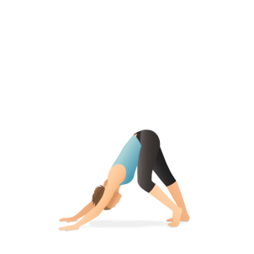
Mountain pose – Start on your hands and knees. Lift your bum up into the air so that your weight is on your hands and feet only. Your toes should be pointing forwards and your knees should be straight. Try to get your heels down. Pull in your tummy muscles so that you are really sturdy like a mountain. Try to hold for 20 seconds and repeat 5 times.
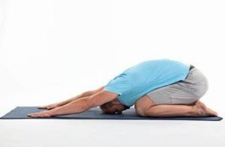
If you find this one tricky, you could do one leg at a time like this picture.

Shell stretch – Start on hands and knees and then sit back on to your heels. Reach your arms out in front as far as is possible and relax all of your muscles. Hold this pose for as long as is comfortable. You should feel fully relaxed while doing it.
- Circuits – doing these circuits as a family will ensure everyone gets their recommended amount of activity. The ultimate goal is to try to do (Circuit 1 x 3 times) + (Circuit 2 x 3 times) + (Circuit 3 x 4 times). However, you will need to build up to this gradually so that you don’t pick up an injury. For example you could try circuit 1 in the morning, circuit 2 in the afternoon and cicruit 3 in the evening, and then gradually build on how many times you do each circuit every day. You can keep track of how many you do using the activity diary below. Remember your muscles will probably be sore the next day after doing these..that’s a good feeling, it means your muscles are getting stronger!!
Circuit 1 - 1A) Jogging on spot/ in hallway/garden x 1minute
1B) Squats or Sit to stands x 15 X 3 Sets, 1 minute rest
1C) Walking /running step ups x 30 between each set

Circuit 2 - 2A) Star jumps x 30
2B) Heel raises x 20 X 3 Sets, 1 minute rest
2C) Wall push up x 10 between each set

Circuit 3 - 3A) Lunges x 10 each leg
3B) Bicycle kicks x 30 X 4 Sets, 1 minute rest
3C) Burpees x 10 between each set
3D) Wall squat x 30 seconds
 | Monday | Tuesday | Wednesday | Thursday | Friday | Saturday | Sunday
Stretches AM
Circuit 1
Circuit 2
Circuit 3
Stretches PM
Other eg walk/cycle
Other eg chores
Other eg family games
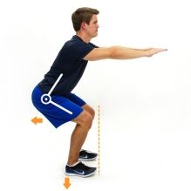
Here are some pictures and explanations of the exercises above in case you are unsure.
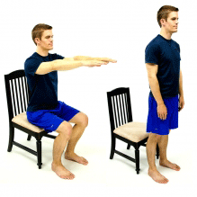
1B) Sit to stands- stand up without using your hands, then squat down to tip your bum off the chair (don’t sit down fully) and then come straight back up to standing.
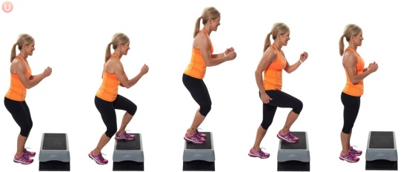
1B) Squats- almost the same as above except the chair is imaginary! Sit your bum back and try not to let your knees come forwards over your toes.
1C) Walking/running step ups – using the bottom step of the stairs step up and down off the step 30 times. Try this walking at first, and then if you find this too easy pick up the speed and do jogging step ups.
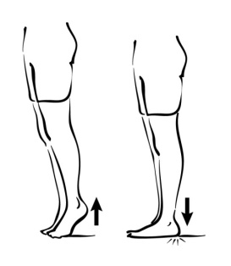
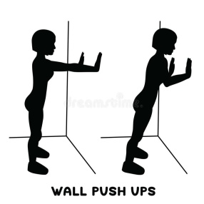
2B) Heel raises – take as little support from the wall as possible, even just one finger. Push up on your tippy toes as tall as you can, hold for 3 seconds at the top, then slowly lower back down in 3 seconds.

2C) Wall push up – stand facing the wall with hands a little wider than shoulder width apart. Tuck in your stomach muscles as you lean your chest in towards the wall. Then push your chest away from the wall. *There should not be any arching of the lower back and you should not feel any discomfort in your lower back*.
3A) Lunges – Take a step out and drop your back knee down towards the ground. Keep your stomach muscles tucked in and your chest upright. *Do not let the knee at the front come forwards over your toes, it should be a right angle like the picture*. This exercise should not cause you any knee discomfort if done correctly.
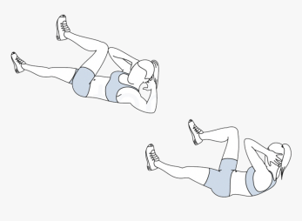
3B) Bicycle kicks – lie on your back with hands behind your head. Try not to pull on your head with your hands, your head is only resting lightly in your hands. Bring opposite knee to opposite elbow and alternate. The slower you go the better for your muscles.
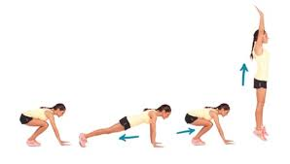
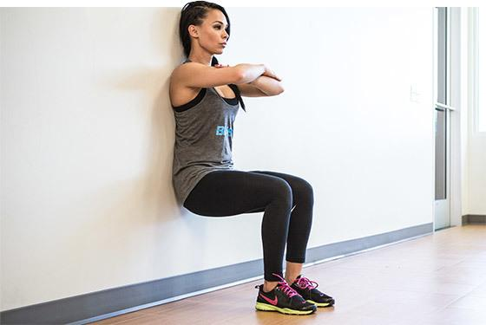
3C) Burpees - jump your feet out to a plank position, then jump them back in towards your hands. Then jump from the ground up as high as you can and repeat. If you find this too tricky, try stepping your feet in and out from your hands rather than jumping, and finish with just one jump.

3D) Wall squat –lean against a wall with your feet hip distance apart. Slide down the wall until your knees are at a right angle like the picture. Your back should be flat against the wall.
- Remember your 60 minutes should be fun , and can be spread out throughout the day, use your imagination ! Here are some last ideas below
- Bring the dog for a walk (if you have one!) within 2 km of your home. If not go for a walk/cycle yourself and get some fresh air.
- Play a game of football/basketball/crab football in the garden if you have one
- If not can you make space at home to pass a small ball or balloon around?
- GoNoodle App
- Just Dance Now App
- P.E lesson with The Body Coach (You tube) 9am every weekday morning.
https://www.youtube.com/channel/UCAxW1XT0iEJo0TYlRfn6rYQ

