Do you have any questions?

How long will it take?
The research takes place over 1-2 months.

Do I need to attend extra appointments?
Study appointments can happen on the same day as other W82GO appointments that you will have.

What happens if I don’t take part?
Your care and treatment will continue as normal with the W82GO service in Temple Street.
What if I take part now but change my mind later?
That’s no problem, you are free to leave the study at any stage.
What do I do to take part?
The researcher will be in touch to see if you are interested. A parent or guardian signs the Certificate of Consent and once this is received, you will be contacted about joining the study.

The Research Team
Dr. Grace O’Malley leads the W82GO service in Temple St. and is organising this research project as part of a bigger European study. There are other BigO study centres in Greece and Sweden.
Lucinda Case is a senior physiotherapist and research assistant working directly with participants of the study in Temple St. Please feel free to contact Lucinda if you would like more information.
Lucinda Case
Phone: 01-8781838
Email: lucinda.case@cuh.ie

Big Data Against Obesity

Enhancing Obesity Treatment

https://bigoprogram.eu

Why have I been chosen for this study?
You have been asked to join the research project as you are participating in the W82GO programme and you are aged 9-16 years old.
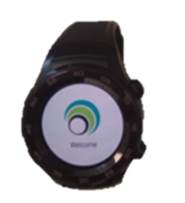
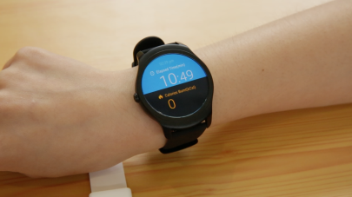
Many children and teenagers don’t exercise enough. We are interested in finding out if measuring activity using a smart watch improves treatment. We are also studying the effect of food ads and are asking children and teenagers in W82GO to capture images so we can measure the types of ads you see.

What is involved?
If you decide to take part, you will be set up with a smartwatch and smartphone app. We will show you how to take pictures using the app and monitor your activity using the smartwatch.
You can decide to wear the smartwatch for:
- 4 weeks continuously
- 2 weeks followed by a break for 8 weeks, followed by 2 weeks again.
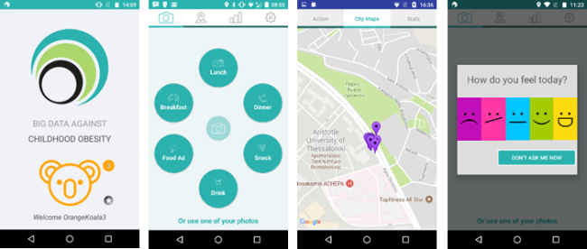
Participants take photos of their meals, snacks and drinks, as well as food ads. Taking part can help you learn about the types of food ads in your neighborhood and how they might affect you. You will also learn more about your activity levels and learn to monitor your own eating habits using photographs.

Using Smartphone Technology
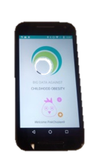

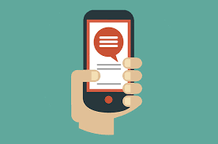
The study involves wearing a smartwatch and using a phone app to take photos of foods you eat and food advertisements in your area.
Confidentiality
The smartphone app and smartwatch and connect to the Internet and collect information about the locations of activity and photographs. The research team take great care to protect your privacy so that no personal information about you is shared outside CHI, Temple Street.
More detail on how we use the information collected is available on the longer information and consent form.

Voluntary Participation
It is up to you and your parent/guardian to decide if you would like to participate or not. You do not have to take part if you don’t want to.

